**17.(Escape sequence) format the following sentence using escape sequence characters only**

**Exercise**

* **format the following sentence using escape sequence characters only**

**Sentence:**

**Dear Xam, this question answer sheet is very helpful for me. Thanks!**

**Output:** 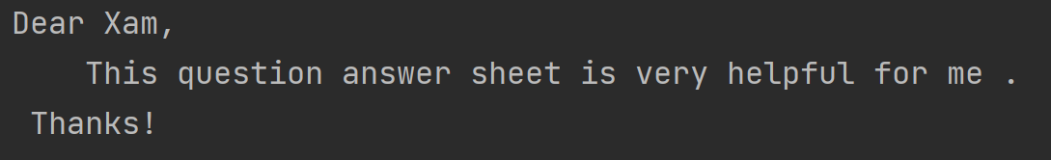

**Approach:**

**So here we did like this**

**Java :**

**Escape Sequence :**

**\t  Inserts a tab in the text at this point.**

**\b  Inserts a backspace in the text at this point.**

**\n  Inserts a newline in the text at this point.**

**\r  Inserts a carriage return in the text at this point.**

**\f  Inserts a form feed in the text at this point.**

**\'  Inserts a single quote character in the text at this point.**

**\"  Inserts a double quote character in the text at this point.**

**\\  Inserts a backslash character in the text at this point.**

**Python :**

**\' Single Quote**

**\”    Double Quote**

**\\ Backslash**

**\n New Line**

**\r Carriage Return**

**\t Tab**

**\b Backspace**

**\f Form Feed**

**\ooo Octal value**

**\xhh Hex value**

**Solution 👇**

**Java :**

**class CodeXam {**

**public static void main(String[] args) {**

**String myLetter = "Dear Xam,\n\tThis question answer sheet is very helpful for me .\n Thanks!";**

**System.out.println(myLetter);**

**}**

**}**

**output:**

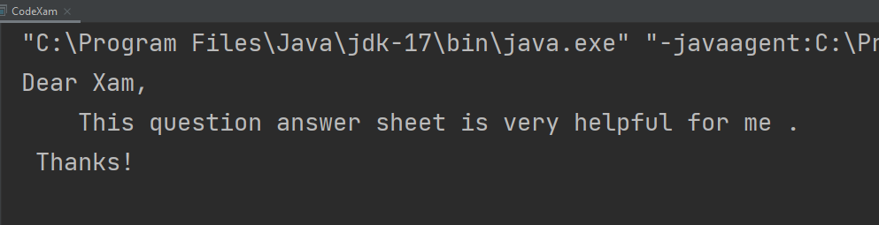

**Python :**

**output = "Dear Suvo,\n\tThis question answer sheet is very helpful for me.\n Thanks!"**

**print(output)**

**output:**

